

(Human Computer Interaction)

Laboratory

1

(Useful and Usable)

|  |  |
| --- | --- |
| **Name of Student** | **Name of Professor** |
| Patrick Dhale A. Concepcion | Ian Cedric Ramirez |
| **Date Performed** | **Date Submitted** |
| Jan 6, 2024 | Jan 6, 2024 |

1. **OBJECTIVES**

At the end of the experiment students must be able to:

Cognitive

1. understand the basic principle of HCI

.

Psychomotor:

1. determine which things are useful and if it is usable

Affective

1. appreciate the concept of usability
2. **BACKGROUND INFORMATION**

In order to accomplish this task, the student must have a clear understanding of the following topics:

* Basic HCI design principles
* Definition of usefulness and usability

1. **PROCEDURES**

Research on a thing (gadget, household item, utensil, etc.) that is useful and somehow usable but was not used or failed to be used by many users. Give background about that thing, where it is made, who made it, when was it released, target users and other related details that is important. The following must be included:

* **Photo** - Put an image of the item that you have selected.
* **Description** - Indicate the item you have selected, describe it physically, is there other items to be used as alternative than this one.
* **Background** - Give background about that thing, where it is made, who made it, when was it released, target users, etc.
* **Assessment** - Indicate here why the item failed to be used by many users given that it is useful and usable. Expound on your answer.

1. **Assessment**

|  |  |
| --- | --- |
| Department | Computer Science |
| Subject Code | CSSELEC4A |
| Description | Human Computer Interaction |
| Term/Academic Year |  |

|  |  |
| --- | --- |
| Topic | HCI Design Principles |
| Lab Activity No | 1 |
| Lab Activity | **Introduction to HCI** |
| CLO | **1** |

**Note: The following rubrics/metrics will be used to grade students’ output in the lab 1.**

|  |  |  |
| --- | --- | --- |
| Criteria | Descriptions | Points |
| Background of the item | The item must be well researched where basic info is presented | 25% |
| Usefulness of the item | Item must be useful and somehow usable for the users even it failed to be used | 25% |
| Explanation | Clarity of the argument for the usability | 30% |
| Presentation | Delivery of the homework | 20% |
| Total |  | 100% |

#### Mouse and touchpad – Navigation of Graphical Interface (GUI)

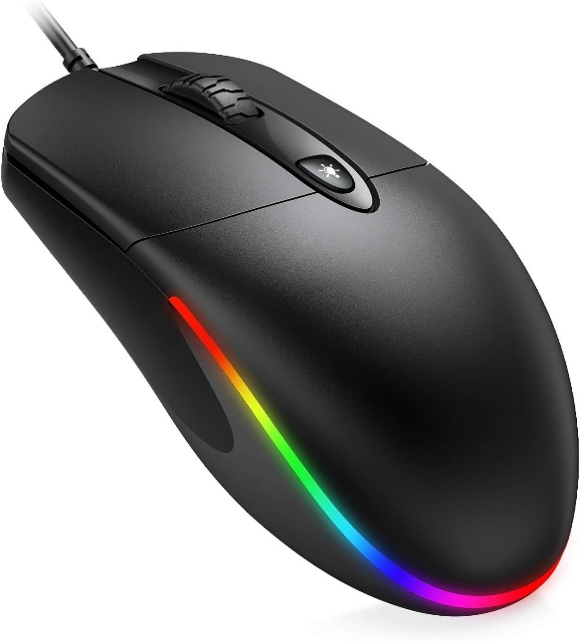

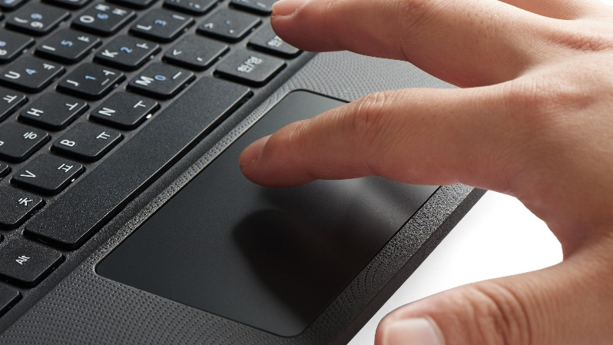

**Descriptions/Background:**

It is a rectangular shape that is integrated in a laptop.

The touchpad was created by Goerge E. Gerpheide in 1988 it was created for the alternative input for the traditional mouse. The trackpad was later popularized by Apple in its PowerBook series of laptops.

The mouse has a shape of a flat, cylindrical or hemispherical shape that has 2 buttons and 1 scroll wheel though some mouse can have more buttons but most mouse only has a minimum of 2 buttons.

The mouse is created by Douglas Engelbart in 1964 it was created as a tool to make navigating a graphical user interface to be much more accessible.

**Assessment:**

The touchpad is useful but not as usable as a mouse, because a mouse has better range of motion when it comes to controlling the cursor and some mouse is modified to have more buttons compare to the traditional one’s for people to use, compare to a touchpad that has only drag motion and 2 buttons.